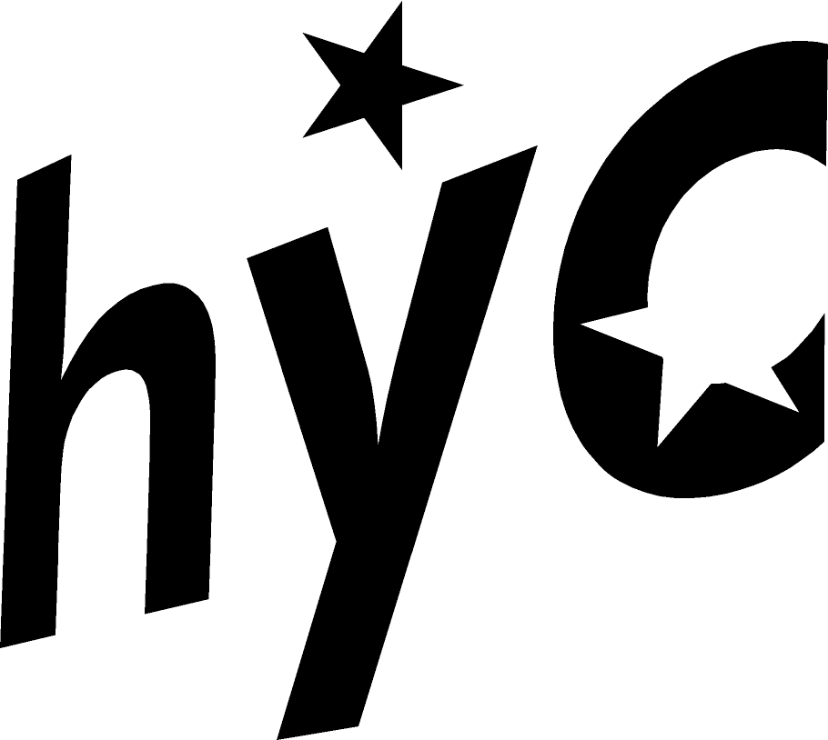
Hilfield Youth Camp, August 15th – 23rd, 2020.
To reserve your place, complete the booking form and return it with a cheque or BACS payment for the full amount or a deposit of at least £40 (£40 non-refundable) to: HYC, c/o Emily Robertson, 2 Ivy Court, Hullavington, Chippenham, Wiltshire, SN14 6RU. We will provide detailed information about this year’s camp in July. Camp costs £130 when booked before May 1st 2020 (£160 after). If you are likely to find it difficult to meet the full cost of camp please contact us, we may be able to help. Please make cheques payable to “Hilfield Youth Camp SSF” or by BACS Sort: 60-20-49, Acc: 67057578. International Bank Transfer Details: BIC NWBK GB 2L. IBAN GB19 NWBK 6020 4967 0575 78.
Camper's Details (block capitals)
Name
Date of Birth
Address
Postcode
Telephone (incl. STD)
Mobile
Email

Parental/Legal Guardian Contact (block capitals)

Please fill in the details of your next-of-kin / legal guardian, who should be contacted in the
unlikely event of an emergency during camp.
Name
Address
Postcode
Home Telephone (incl. STD)
Mobile
Work Telephone
Email

Parental/Legal Guardian Permission
If you will be under 18 whilst on camp, please ask your parent or legal guardian to complete and sign this part of the form:
I am happy for to attend the 2020 Hilfield Youth Camp.
Signed: (Parent/Guardian)

Information: Emily Robertson, Tel. 07974947327, hilfieldyouthcamp@gmail.com. www.hilfieldyouthcamp.co.uk
Please note: details collected on this form may be held on a computer and used solely by Hilfield Youth Camp in the course of its administrative duties. Final booking deadline is July 5th 2020. If you wish to book after this date please contact Emily on 07974947327.

